**Demographics:**

1. **Patient Distribution**:

**Que - What is the distribution of patients by gender, age group, or blood type?**

SELECT Count(Name), Gender FROM cleaned_healthcare

GROUP BY gender

SELECT CASE

WHEN Age < 10 THEN '<10'

WHEN Age BETWEEN 10 AND 19 THEN '10-19'

WHEN Age BETWEEN 20 AND 39 THEN '20-39'

WHEN Age BETWEEN 40 AND 59 THEN '40-59'

WHEN Age > 60 THEN '60+' END AS Age_Group,

Count(*) AS Total FROM Cleaned_healthcare

GROUP BY Age_Group

ORDER BY Age_Group;

SELECT COUNT(Name), blood_type FROM cleaned_healthcare

GROUP BY blood_type;

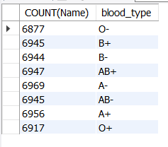

**Que - How many patients belong to each medical condition?**

SELECT COUNT(Name) AS Patient_Name, medical_condition

FROM cleaned_healthcare

GROUP BY medical_condition

1. **Insurance Insights**:

**Que - Which insurance providers cover the most patients?**

SELECT COUNT(Name) AS Patient_Name, insurance_provider FROM cleaned_healthcare

GROUP BY insurance_provider

ORDER BY insurance_provider DESC

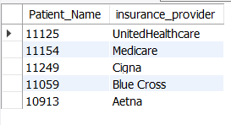

* + **Que - What is the average billing amount per insurance provider?**

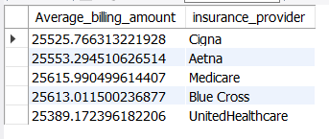

**Financial Analysis:**

1. **Billing Insights**:
   * **Que - What is the average billing amount by medical condition?**

SELECT Avg(billing_amount) AS Average_billing_amount,

medical_condition FROM cleaned_healthcare

GROUP BY medical_condition

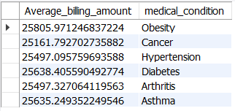

* + **Que - Identify the top 10 highest billing cases and their details.**

SELECT billing_amount,

Name, Age, admission_type FROM cleaned_healthcare

ORDER BY billing_amount DESC LIMIT 10

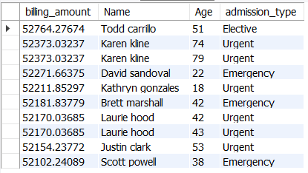

1. **Treatment Costs**:
   * **Que - Is there a correlation between admission type (emergency vs. elective) and billing amounts?**

SELECT admission_type,

COUNT(*) AS Total_Admissions,

ROUND(AVG(billing_amount), 2) AS Avg_billing_amount,

ROUND(Min(billing_amount), 2) AS Min_billing_amount,

ROUND(Max(billing_amount), 2) AS Max_billing_amount,

ROUND(STDDEV(billing_amount), 2) AS STDDEV_billing_amount

FROM cleaned_healthcare

GROUP BY admission_type;

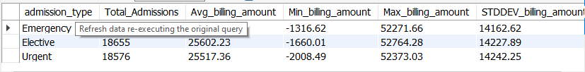

**Medical Insights:**

1. **Condition and Treatment Analysis**:
   * **Que - Which medical conditions have the longest average stay duration?**

SELECT medical_condition, SUM((discharge_date)-(date_of_admission))

AS Patient_duration FROM cleaned_healthcare

GROUP BY medical_condition

ORDER BY Patient_duration DESC

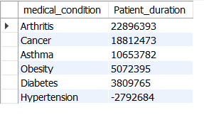

* + **Que - Are there trends in test results (normal vs. abnormal) for specific conditions?**

SELECT medical_condition, test_results,

COUNT(*) AS result_count

FROM cleaned_healthcare

GROUP BY medical_condition, test_results

ORDER BY medical_condition, test_results;

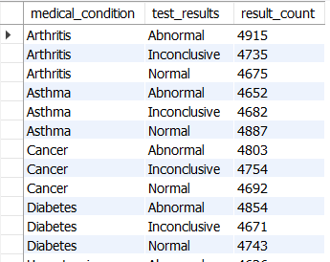

1. **Doctor Performance**:
   * **Que - Which doctors handle the most patients?**

SELECT Doctor, COUNT(Name) AS Patients

FROM cleaned_healthcare

GROUP BY Doctor

ORDER BY Patients DESC;

* + **Que - Are there significant differences in treatment outcomes among doctors?**

SELECT Doctor, COUNT(Name) AS Patients, test_results,

COUNT(*) AS results

FROM cleaned_healthcare

GROUP BY Doctor, test_results

ORDER BY Patients DESC;

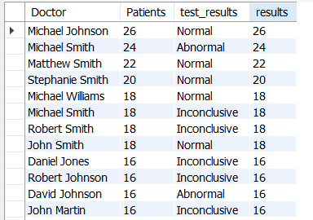

**Temporal Trends:**

1. **Time-Based Trends**:
   * **Que - What are the admission trends over time (e.g., by month or year)?**

SELECT DATE_FORMAT(date_of_admission, '%M') AS Month_Name,

COUNT(Name) AS Patient_Count FROM cleaned_healthcare

GROUP BY MONTH(date_of_admission), Month_Name

ORDER BY MONTH(date_of_admission) ASC;

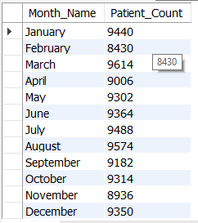

SELECT DATE_FORMAT(date_of_admission, '%Y') AS year_,

COUNT(Name) AS Patient_Count FROM cleaned_healthcare

GROUP BY YEAR(date_of_admission), year_

ORDER BY YEAR(date_of_admission) ASC;

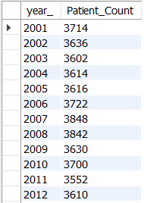

* + **Que - Are there seasonal trends in medical conditions or treatments?**

Seasonal Trends of Medical Condition –

SELECT CASE

WHEN MONTH(date_of_admission) IN (12,1,2) THEN 'Winter'

WHEN MONTH(date_of_admission) IN (3,4,5) THEN 'Spring'

WHEN MONTH(date_of_admission) IN (6,7,8) THEN 'Summer'

WHEN MONTH(date_of_admission) IN (9,10,11) THEN 'Fall'

END AS Season,

medical_condition,

COUNT(*) AS Condition_count

FROM cleaned_healthcare

GROUP BY season, medical_condition

ORDER BY season, Condition_count DESC;

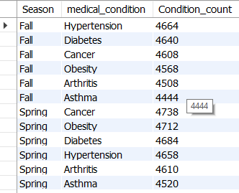

Seasonal Trend of medications -

SELECT CASE

WHEN MONTH(date_of_admission) IN (12,1,2) THEN 'Winter'

WHEN MONTH(date_of_admission) IN (3,4,5) THEN 'Spring'

WHEN MONTH(date_of_admission) IN (6,7,8) THEN 'Summer'

WHEN MONTH(date_of_admission) IN (9,10,11) THEN 'Fall'

END AS Season,

Medication,

COUNT(*) AS Medication_count

FROM cleaned_healthcare

GROUP BY season, Medication

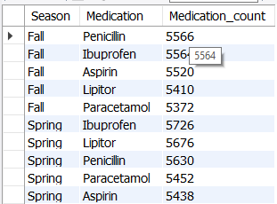ORDER BY season, Medication_count DESC;

